**Machine Learning**

**Naïve Bayes:**  
Run : python NaiveBayes.py <Train data directory><Test data directory><NLTK Tokenizer(Boolean)>

Example : python NaiveBayes.py train test true

Results :

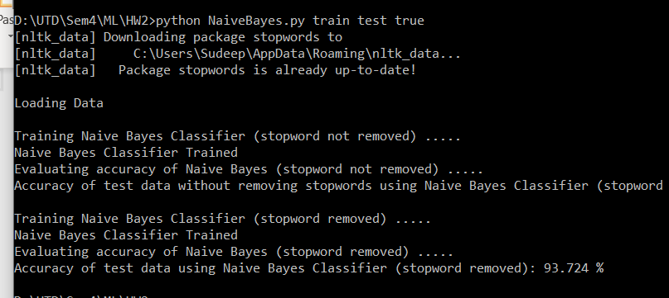

Note: the program Output contains the result for both stop words not removed and with stop words remove.

Logistic Regression:

Run : python NaiveBayes.py <Train data directory><Test data directory><Lambda Values><no. of iterations><remove_StopWords(true/false)>

Example: python LogisticRegression.py train test 0.0 10 false

Results: for 10 iteration

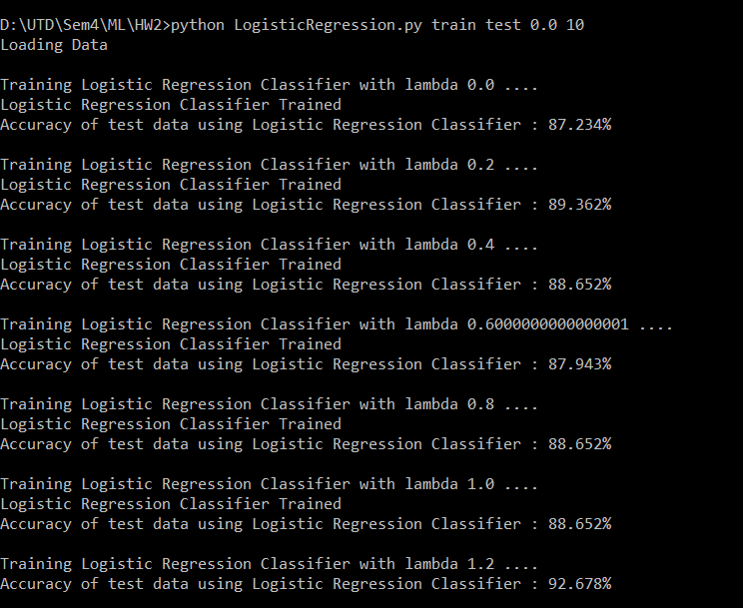

Result for 25 iteration:

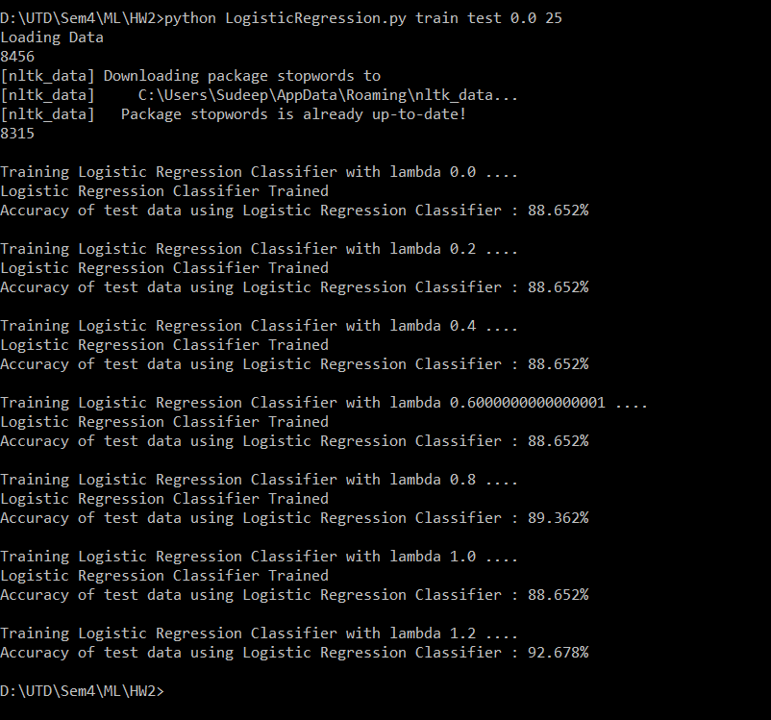

Results of removing Stop Words:  
Command : python LogisticRegression.py train test 0.0 10 true

